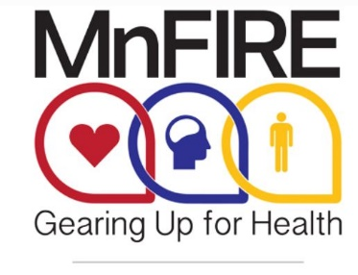
[Insert Date]

Dear First Name,

The Minnesota Firefighter Initiative (MnFIRE) is dedicated to providing Minnesota’s firefighters with the tools they need to prioritize and protect their health. Cardiovascular disease is the number one killer of firefighters nationwide and is by far the leading cause of line-of-duty deaths in the fire service. Firefighters also suffer from cancer and emotional trauma at a much higher rate than the general public.
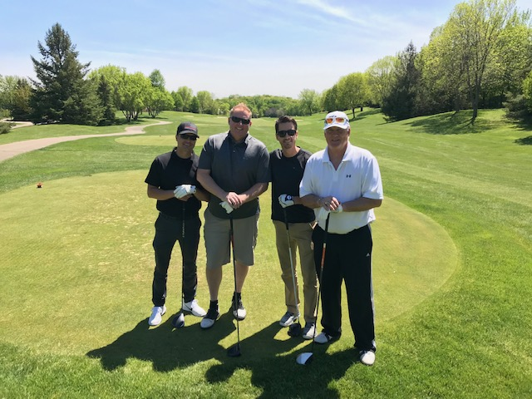
Minnesota currently ranks 48th in the nation per-capita in fire service spending. MnFIRE is committed to bridging this gap for firefighters and their families. With your help, we can reverse the trend of illness, disease, and death in those who dedicate their lives to providing life-saving services for you and communities all across Minnesota.
Your sponsorship and participation in MnFORE – MnFIRE’s signature Golf Tournament – on May 24, 2021 at Bearpath Golf Course in Eden Prairie, will provide much-needed funding for Minnesota firefighters. It will help ensure that more firefighters receive the life-saving services in three key program areas: heart health, emotional trauma, and cancer prevention and support.
This fun and hope-filled event includes 18 holes of golf (best-shot scramble), cart, boxed lunch, seated dinner, silent auction, contests and raffle prizes.
Please consider sponsoring MnFORE at one of the levels outlined in the enclosed sponsorship document. As an event sponsor, your business or organization will be recognized and highlighted in many ways throughout the promotion of the event, at the event and following the event. To discuss a custom sponsor package, call MnFIRE president George Esbensen at 763-242-1819.

Sincerely,

George Esbensen
MnFIRE President
gesbensen@mnfireinitiative.com
763-242-1819

Gina Calistro
MnFire Event Coordinator
gcalistro@mnfireinitiative.com
612-309-4462

MnFIRE is a 501(c)(3) nonprofit and your gift is tax deductible to the full extent provided by law. Tax ID: 38-4049248

SPONSORSHIP OPPORTUNITIES

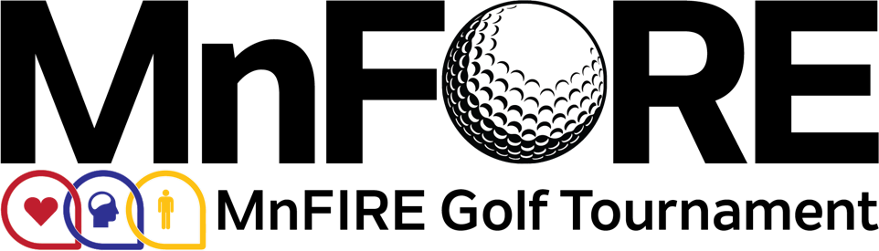

MnFIRE appreciates all the support you have provided in the past and we’d like to ask you to support MnFORE, our signature golf tournament, which provides much-needed funding for Minnesota firefighters. It will help ensure that more firefighters receive the life-saving services in three key program areas: heart health, emotional trauma, and cancer prevention and support.
Your support goes a long way as this serves as our most significant annual fundraiser. We are proud to promote all of our sponsors before the event on our website and through our various social media channels, during the event on various signage and press coverage, and after the event within our post-event wrap-up and thank you correspondence to our participants.
The following outlines the available sponsorship levels. We are also extremely appreciative for any prizes or monetary gift that your organization is able to contribute to support our Silent Auction and Raffle at the golf tournament.

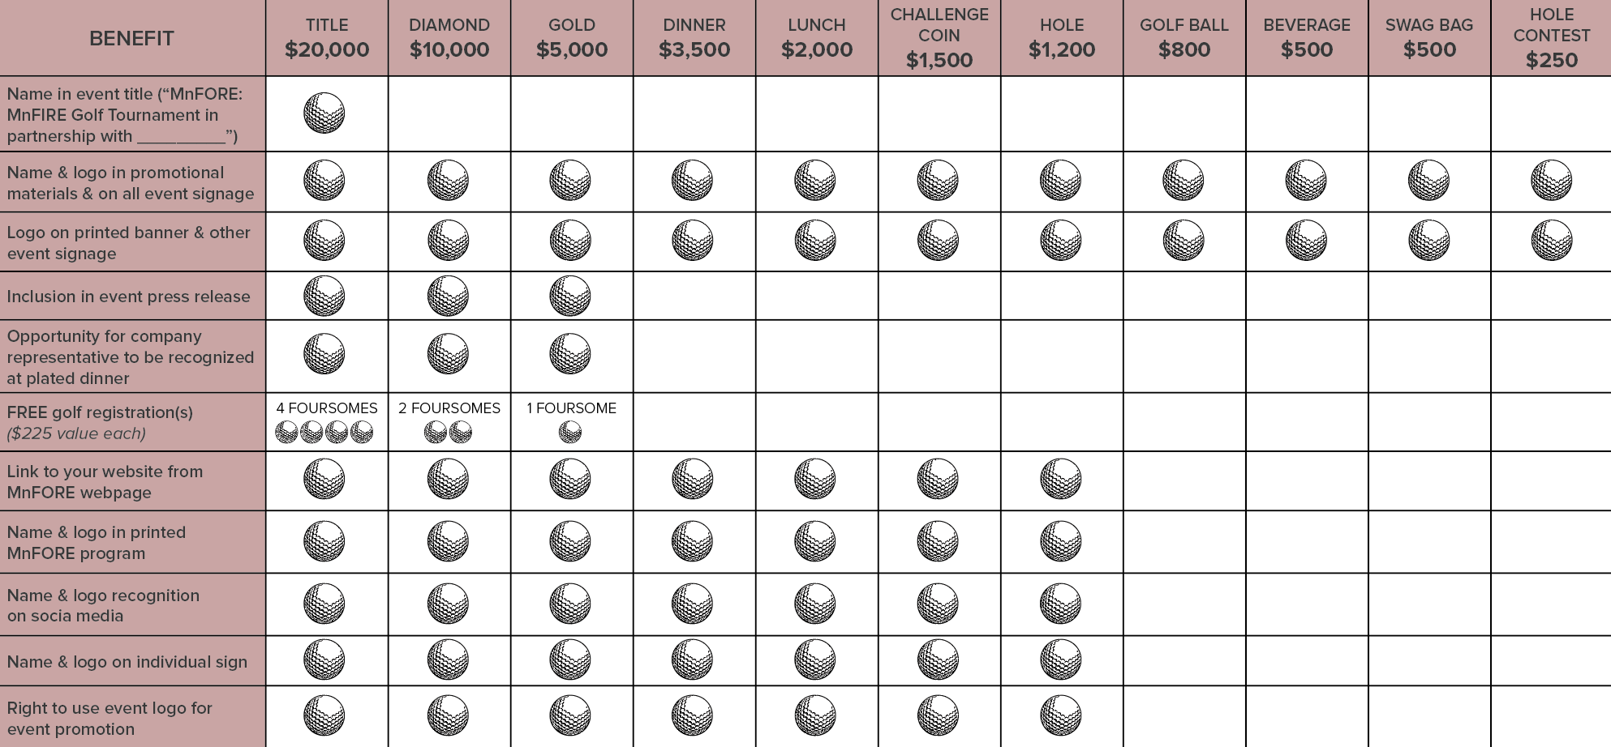

All sponsors will be recognized and gratefully acknowledged onsite at the tournament and in media publications.

Please mail donations to:
MnFIRE c/o St. Louis Park Fire Station #1
Attention: John Wolff
3750 Woodale Avenue South, St. Louis Park, MN 55416

Personal pick-up is available by contacting Gina Calistro at gcalistro@mnfireinitiative.com or 612-309-4462.

